Learner SOP for using Fusion – ELTPs

Marking attendance in Fusion:

1. Go to Pi home page – Click on All Apps
2. Click on **Fusion Learning** under **Learning & Development** tab (Click on Company single sign in)
3. Click on **“Learning”** tab in **Me** option Click **“Current Learning”**
4. Click on session nameswhich you have attended
5. Click on “**Mark Completed button”** for the days on which you were present.

**Note: Attendance should be marked only for the days when you are present for the session. In case it is observed that anyone marks their attendance falsely, disciplinary action would be taken against the person!**

Filling feedback in Fusion: (You need to do post completion of session)

1. Go to Pi home page – Click on All Apps
2. Click on **Fusion Learning** under **Learning & Development** tab (Click on Company single sign in)
3. Click on **“Learning”** tab in **Me** option Click **“Current Learning”**
4. Click on session nameswhich you have attended
5. Click on **“Take Assessment”** tab (This Tab is for trainer feedback)
6. Click on **“Evaluation”** tab ((This Tab is for training feedback)
7. Demo screenshots given below:

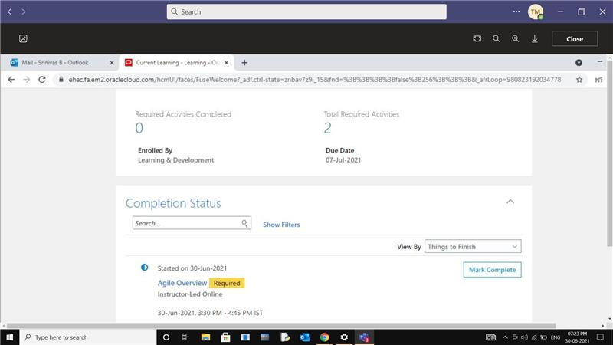

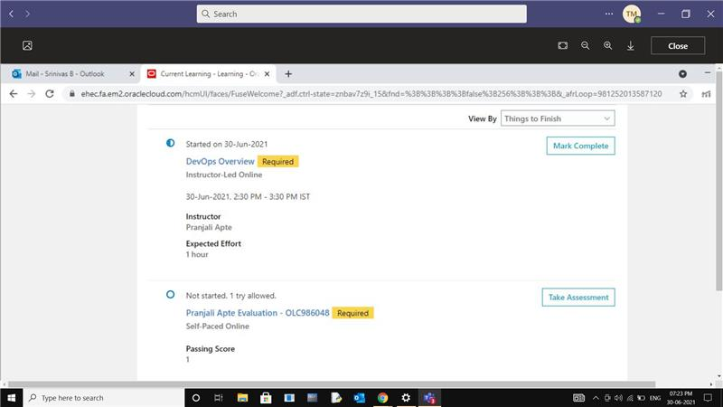

**Note: Please note, you need to complete all the activities including feedback (trainer evaluation and training evaluation) form for every training you attend.**